**COVID HELPER - CoBot**

**-FOR ALL YOUR NEEDS**



**TEAM DETAILS:**

**Team name:** TESSERACT

**Team member 1**: CHINTALA SANTOSHI REDDY

**Team member 2**: PAMIREDDY MEGHANA

**Team member 3**: AMINA AFSA

**SOLUTION BRIEF OVERVIEW:**

Covid Helper - CoBot, for all our needs. This chatbot is all about coronavirus. It gives the detailed information about what coronavirus is; how it is originated; symptoms & prevention. We also added some important things with links/images which makes us understand better, like latest updates about COVID-19 vaccines; cases being registered world wide; how to disinfect your food/surroundings/objects around you; how to boost your immunity; stress management. Most importantly alternative career options and books/courses for free.

**WORKING MODEL:**

**SOURCE CODE:**

**TECHNOLOGY & IT’S VITAL ROLE DURING PANDEMIC:**



Technology cannot prevent the onset of the pandemics; however, it can help prevent the spread, educate, warn, and empower those on the ground to be aware of the situation, and noticeably lessen the impact***.*** Today, with converging technologies like mobile, cloud, analytics, robotics, AI/ML, 4G/5G, and high-speed internet, it has become possible to test several innovative approaches to pandemic response. Here, we have listed eight such areas where technology play a vital role:

1) **Fighting misinformation.**

2) **Finding Drugs.**

3) **Increasing traceability and transparency by sharing data.**

4) **Tracking people with facial recognition and big data.**

5) **How China is using Big Data & AI to fight the Corona virus.**

6) **Contact-less movement and deliveries through autonomous vehicles, drones and robots.**

7) **Technology supported temperature monitoring.**

8) **Remote working technologies to support social distancing and maintain business continuity.**

**SOLUTION DESCRIPTION:**

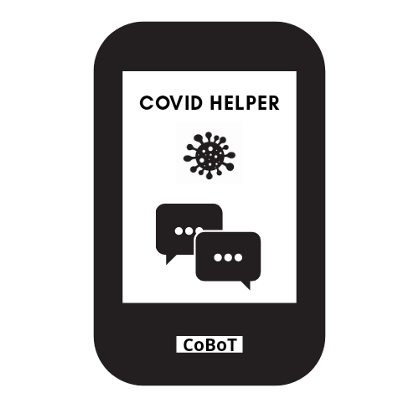

**Covid Helper- CoBot was designed to know the detailed information about coronavirus and all it’s factors. It basically gives updates and lastest news about coronavirus, vaccines/medicine, cases around the globe. Also basic information about how it is spread, originated reasons, prevention etc.**

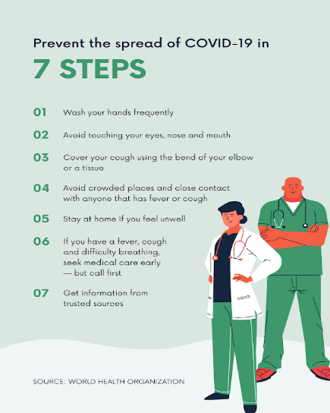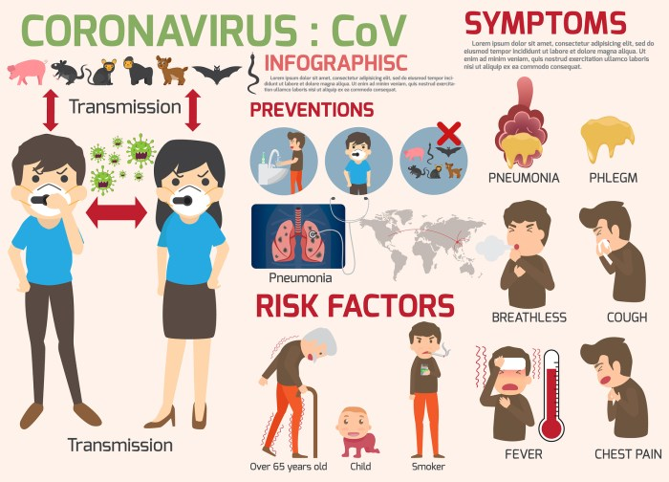

**We provided information with youtube links were people can understand very well. Also gave detailed and step by step procedures for quarantine; mask; disinfecting surfaces/fruits & vegetables; boost your immunity; prevention methods.**



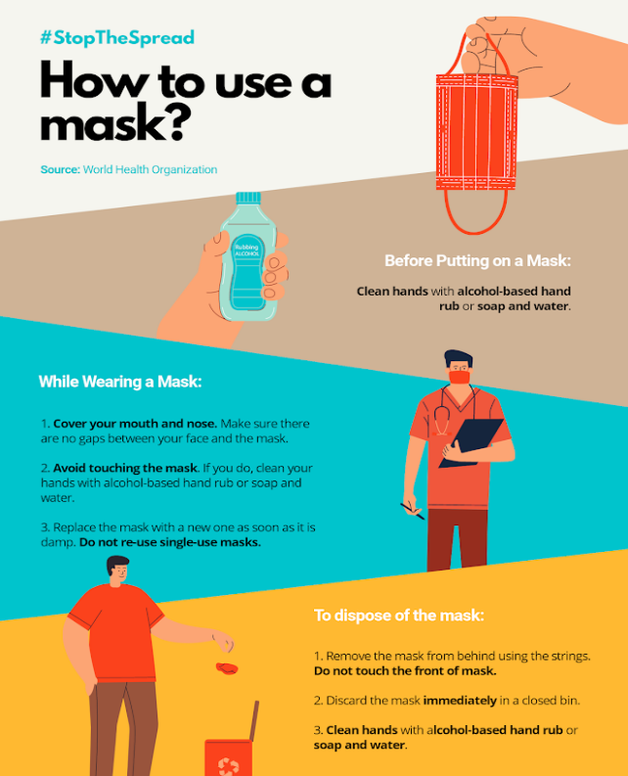

As the world faces unprecedented challenges and workplaces experience increasing pressure, now more than ever taking charge of your career is essential. **The main solution of this Covid Helper- CoBot is showcase different career options during this pandemic and find free books/courses for students. Alternative career options we mentioned are:**

1. **Blogging**
2. **Online training and education**
3. **Volunteering**
4. **Farming at home**



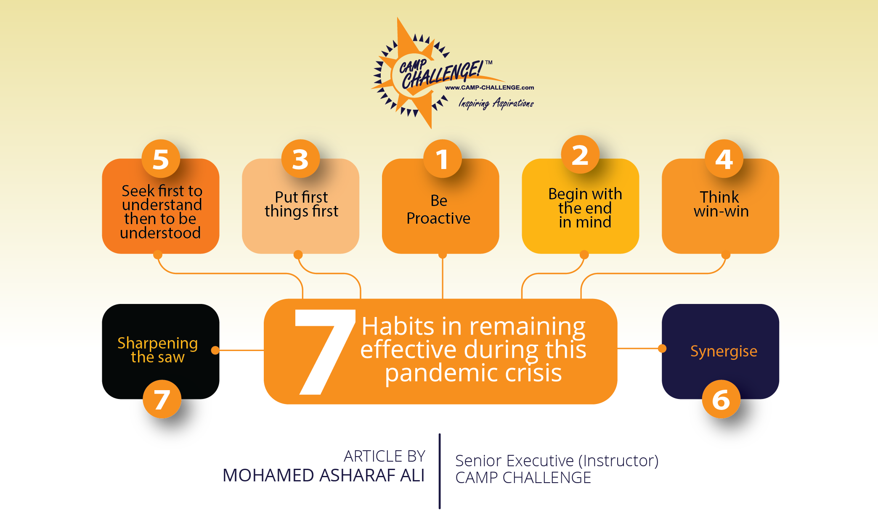

**This solution may help people not to worried about their career and education life. And always stay health and be protective at home or while going out. It also gives some tips about healthy habits.**

**SOLUTION ARCHITECTURE:**

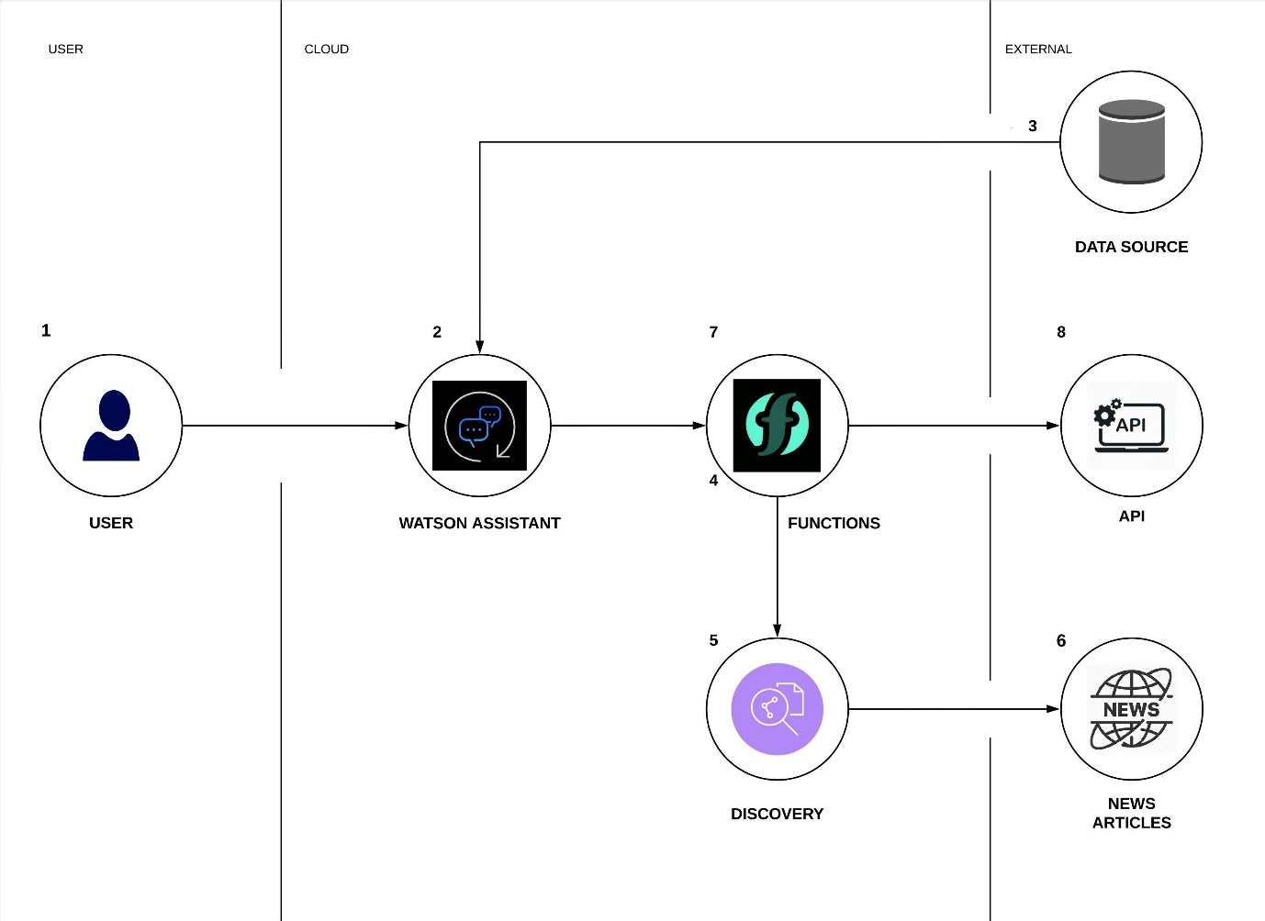

**The above picture shows about the architectural overview of the Covid Helper- CoBot.**

1. **User asks a query to the chatbot. The chatbot then takes the input responds to the user based on the given query.**
2. **With the help of Watson Assistant, it collects information from data source and articles provided by the discovery service.**
3. In functions, we can run code on-demand with HTTP-based API requests from applications or run code in response to IBM Cloud services and third-party events.
4. Then, after collecting the information it returns the answer for given query.

**IBM CLOUD SERVICES/SYSTEMS:**

**IBM WATSON ASSISTANT:** Using IBM Watson Assistant we can build our own branded live chatbot into any device, application, or channel. Chatbot, which is also known as an assistant, connects to the customer engagement resources that are already use to deliver an engaging, unified problem-solving experience to the customers.

**IBM CLOUD FUNCTIONS:** With IBM Cloud Functions, we can use our favorite programming language to write lightweight code that runs app logic in a scalable way. You can run code on-demand with HTTP-based API requests from applications or run code in response to IBM Cloud services and third-party events. The Function-as-a-Service (FaaS) programming platform is based on the open source project Apache OpenWhisk.

**IBM WATSON DISCOVERY:** IBM Watson Discovery makes it possible to rapidly build cognitive, cloud-based exploration applications that unlock actionable insights hidden in unstructured data — including your own proprietary data, as well as public and third-party data. With Discovery, it only takes a few steps to prepare your unstructured data, create a query that pinpoints the information you need, and then integrate those insights into your new application or existing solution.